**Hour dataset**

I’ve created correlation plot of all variables to check correlation between them and exclude variables which are correlated between each other and with dependent variable (cnt).

Considering results of this plot I exclude from model variables “registered”, “casual” and “atemp” to avoid collinearity. Leave variable “temp” because it’s more significant than “atemp” according to summary table.

Excluding “workingday” because it’s insignificant

Model after excluding variables:

Result of the model:

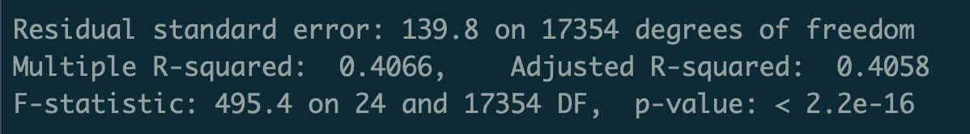

Building non-linear model:

Result of the model:­

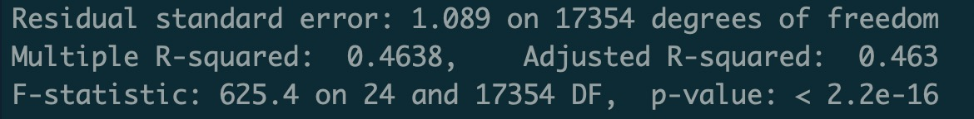

Considering R-squared in this dataset – non-linear model preforms better.

**Day dataset**

After making the same operations with this dataset I’ve got such models:

model after excluding variables:

Result of the model:

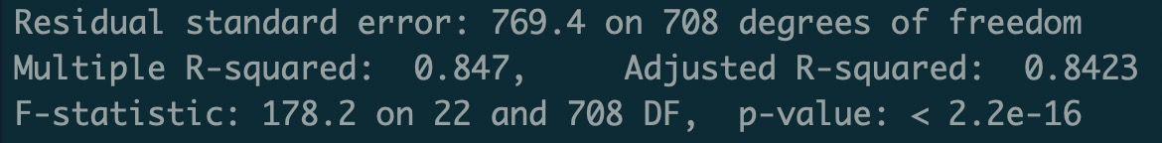

Building non-linear model:

Result of the model:

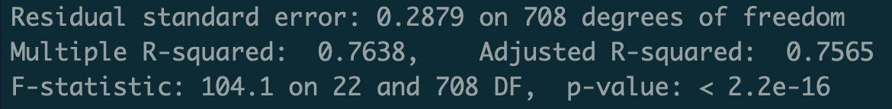

Considering R-squared in this dataset - linear model performs better than non-linear.